The MicroTravel
from
Comp-Co.
User Manual
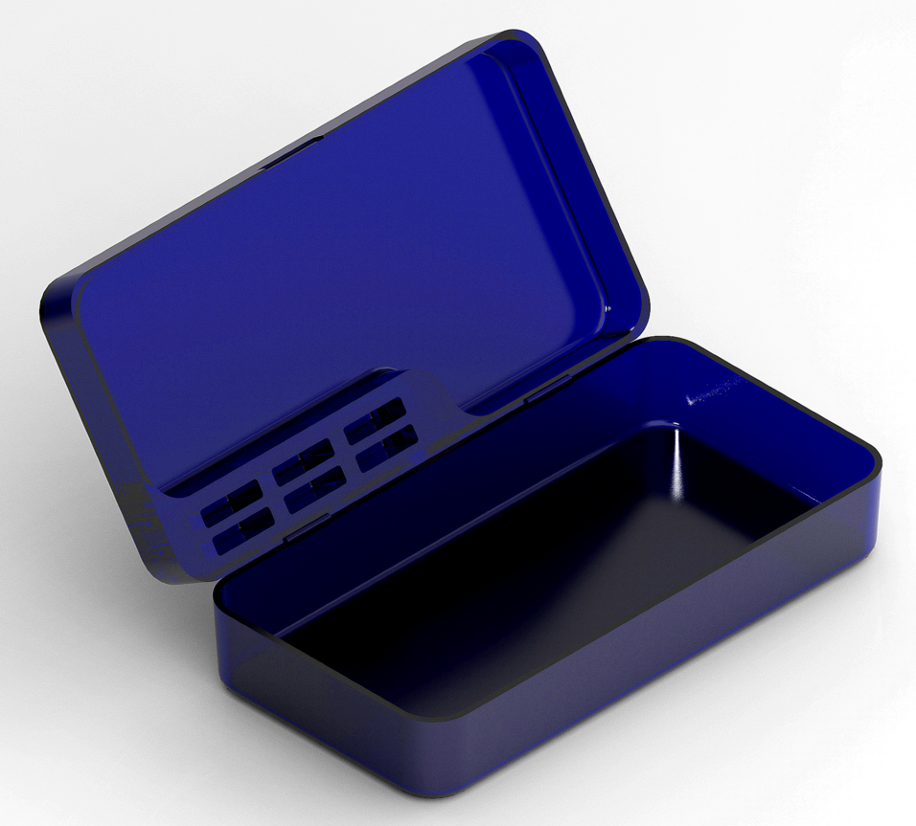
IT IS SUGGESTED THAT ALL USERS READ THIS MANUAL BEFORE USING THE MicroTravel
Comp-Co. MicroTravel

Table of Contents

Included Items……………………………………..3
Assembly.............................................................3
Initial Setup and Use...........................................4, 5
Maintenance / Cleaning.......................................5
Safety Information................................................6
Warranty Information............................................6
Support.................................................................7

Included Items
Included in every MicroTravel box is:

- The MicroTravel Toiletry Case
- A card with QR Codes linking to our website, user manual, support page, 3D printable model download, and DIY hinge prep guide.
- A card with warranty registration information.
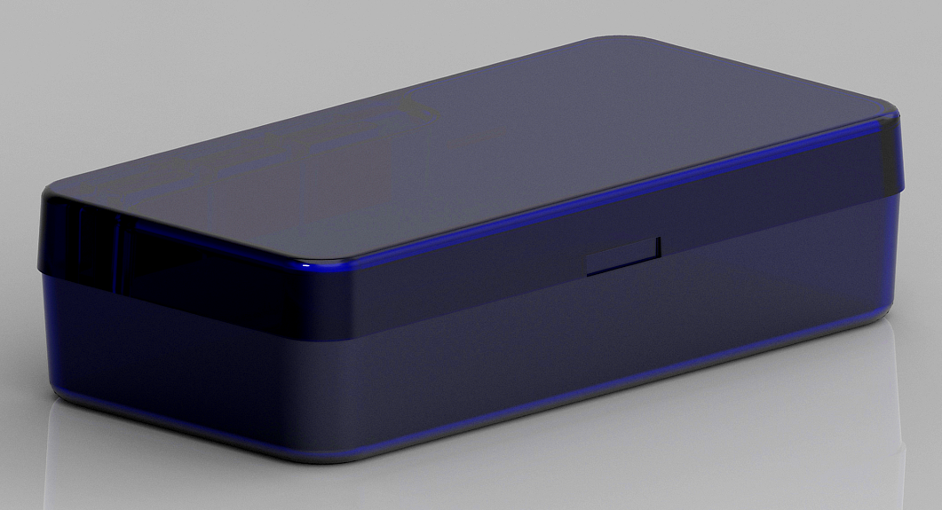

Assembly
Thanks to our unique compliant mechanism hinges, the MicroTravel requires no assembly! Just take it out of the box, and get straight to using it.
Note: The MicroTravel cannot be disassembled.

Initial Setup and Use
The compliant hinges on the MicroTravel are ‘broken in’ prior to shipping, at the factory, allowing it to be ready for use straight out of the box!
Note: If you have 3D printed your own MicroTravel, you will need to follow the DIY hinge prep guide to properly ‘break in’ the compliant hinges.

The MicroTravel has space for many common bathroom utensils, such as a toothbrush, comb, razor, or toothpaste, and even larger items, such as shaving cream, deodorant, or floss.


The holes in the lid of the MicroTravel are there to stand up commonly sized utensils, and leaves plenty of room in the main body for standing up other items.
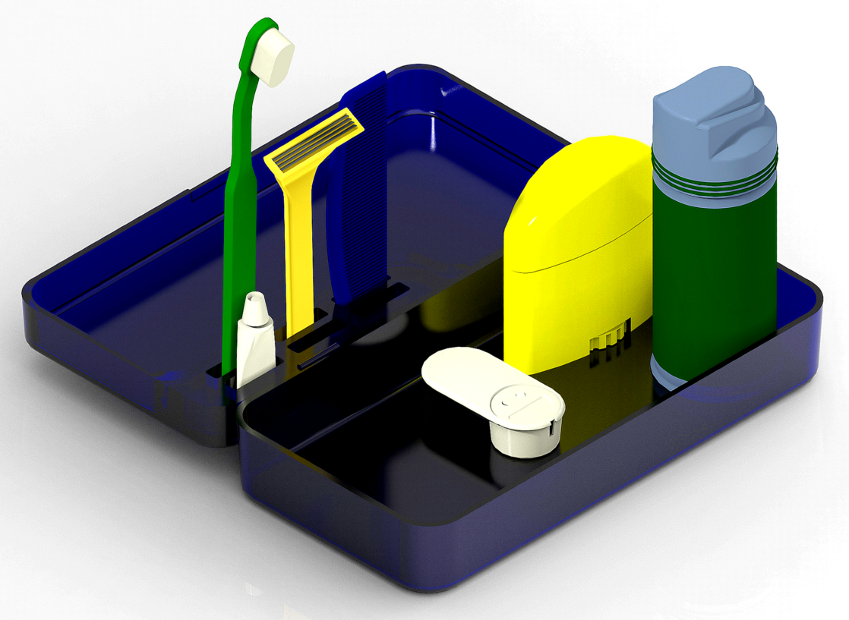

Maintenance / Cleaning
The MicroTravel does not require maintenance of any kind, due to its plastic material, as well as its lack of moving parts.
The compliant hinges on the MicroTravel are rated for over 100,000 open and close cycles and will slightly loosen as they progress toward their end of life.

To clean the MicroTravel, simply use warm water, dish / hand soap, and a sponge or other gunk-cleaning utensil.

Safety Information
CALIFORNIA PROPOSITION 65 WARNING
This product contains chemicals known to the State of California to cause cancer and birth defects or other reproductive harm.
For more information: www.P65Warnings.ca.gov

The MicroTravel is made of carbon-infused PETG plastic. If the MicroTravel is ever broken, microscopic fragments of carbon CAN become airborne and cause respiratory issues, however, this has yet to happen in our in-house safety testing.

Warranty Information
The MicroTravel is backed by our 30-Day Money-Back Guarantee. If you are not satisfied with the product, visit our support website.
The hinges on the MicroTravel are backed by a 1-year full warranty. If the compliant hinges on your MicroTravel break from normal use within the first year of ownership, we will replace your MicroTravel for free!
An additional year of limited warranty is also included with every purchase.

Support
As of the last revision of the MicroTravel User Manual, the following information is correct. Please refer to our website for our latest email, phone number, and mailing address.

Main Website:
https://webpages.charlotte.edu/acurrie9/project.html

Support Site:
comp.co/MicroTravel

Support Phone Number:
+1 (980) 505 2023

Mailing Address:
9201 University City Blvd.
Charlotte, NC 28223

Inquiries:
Aidan Currie
CEO, Comp-Co.
acurrie9@uncc.edu

